**Design of the Level**

The track is to be split into three different sections to make play as enjoyable as possible.

**Stage One**

The first stage of the track is to be designed around affordances, this part will be very easy, the speed boost will be placed in an easy to reach position so that players can learn what they do by simply moving into it and seeing the effect.

This stage of the game will last approximately 6-10 seconds, as it will likely be the least interesting to most players as the level of skill required is very low.

This section can be broken down into three hill sections

1. An initial very steep hill to spawn at the top of, this shows players the momentum they can gain from going downhill.
2. At the bottom of the hill the second hill starts with a shallow incline, this makes it very easy to jump over even if the player begins climbing up it and losing momentum from the steep hill.  
   The purpose of this is to show players how climbing uphill can greatly reduce your momentum and that jumping can avoid this.
3. The final part is a long downward slope towards a speed boost near the bottom which is very easy to obtain (Little risk). This has two purposes, players that lost momentum on the previous incline can gain it back for the main stage through the downward slope and the speed boost and it also allows players to try the speed boost for the (potentially) first time in a safe part of the track.

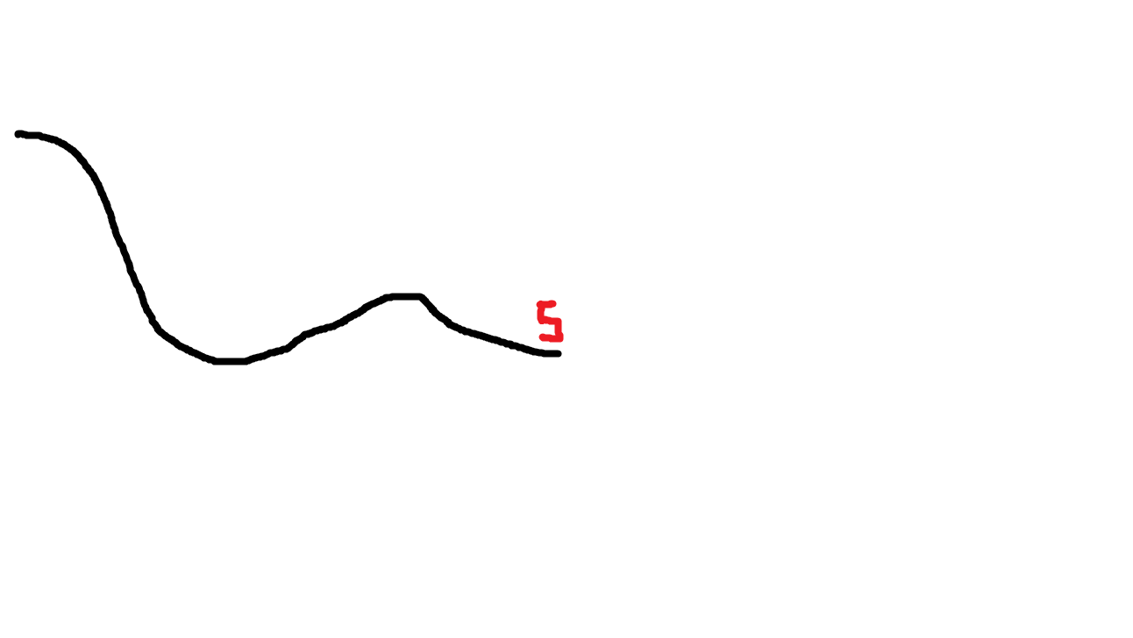

**Stage Two**

This stage is the core of the track and would last up to a minute and a half, the track starts with rolling hills to give the players a chance to play without the affordances offered in the first stage but quickly moves onto both tall and shallow hills that become more challenging as the game goes on. While we play test, this section will be a short repeating section which will become more distinct and unique as we gain more information about how players play.

At this stage Speed Boosts are only offered at a risk, either late jumps or early jumps are needed to try and get the speed boost, this gives the player choice and offers Risk Vs Reward for players.

This can also act as a “catching up” mechanic for players who are behind and want to try and get back in the game. If they fail the game comes to a swift conclusion which avoids people checking out, and if they succeed the competition continues and so in theory should enjoyment and engagement.

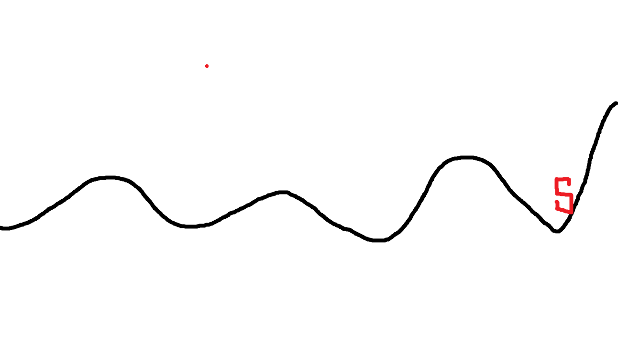

This an **example of a small section** of this stage, speed boosts can be found in difficult to reach locations and the jumps are varied to ensure that players can stumble at any point, it also offers an opportunity to create pseudo feedback loops to keep players interested and to make the game seem more undecided than it is.

**Stage Three**

The final stage of the track is unlikely to be encountered by most players and is intended to end the game before it gets boring or stale. A few very challenging hills precede a flat (the bottom of the hill) plane where players will eventually finish moving. If somehow both players manage to get all the way to this section the one with the most momentum left will win as they will be the last to stop moving on the track.

In total this section will last no more than 20 seconds. 